***ME 554 Finite Element Analysis - Computer Project #1***

## Spring Semester 2018

Diego Ricardo Higueras Ruiz

**Learning Objective:**

* Verify that the results that you get using finite element software match the results that you get doing the stiffness method by hand.

**Instructions:** Please solve the following problem using ANSYS (or other FEA software package)

A truss problem – problem 19 from Chapter 2 of your textbook. Note this is a problem you already solved for homework using the direct stiffness method. Similar to the problem in the homework, please calculate nodal displacements and element forces/stresses using FEA software, compare your results to what you obtained for the homework problem.



E = 1011 Pa, A = 10-4 m2, L=1 m, F=14,142 N

* **Introduction** *(5 points)*

In this problem we are asked to solve a 2D structural problem (truss) by using a FEA software and compere with the obtained results from the homework set. Both problems are solved by the same method; however, in the HW set #4 we are asked to do it by hand, which is perfectly possible due to the simplicity of the problem. For this problem, we expect the node 3 to move downward and to the right side (negative X) and have its element 1 in tension and 2 in compression.

* **Model Development** *(20 points)*

In the illustration below, we can see the model used for this problem. For this project I have tried to different methods. First I have define keypoints and lines, after this modeling process I created a mesh for this geometric figures, (Size control 🡪 Manual Size 🡪 All lines “all lines as one” with 2 as the number of division per elements). The second method was to define nodes and elements from the beginning. The results shown in this report are for the second method.

The image shows the constrain in the node 1 and 3 and the two component of the force that we have applied on the node 2.

Assumptions:

* The material is consider isotropic.
* 2-D problem.
* Linear elastic material behavior.

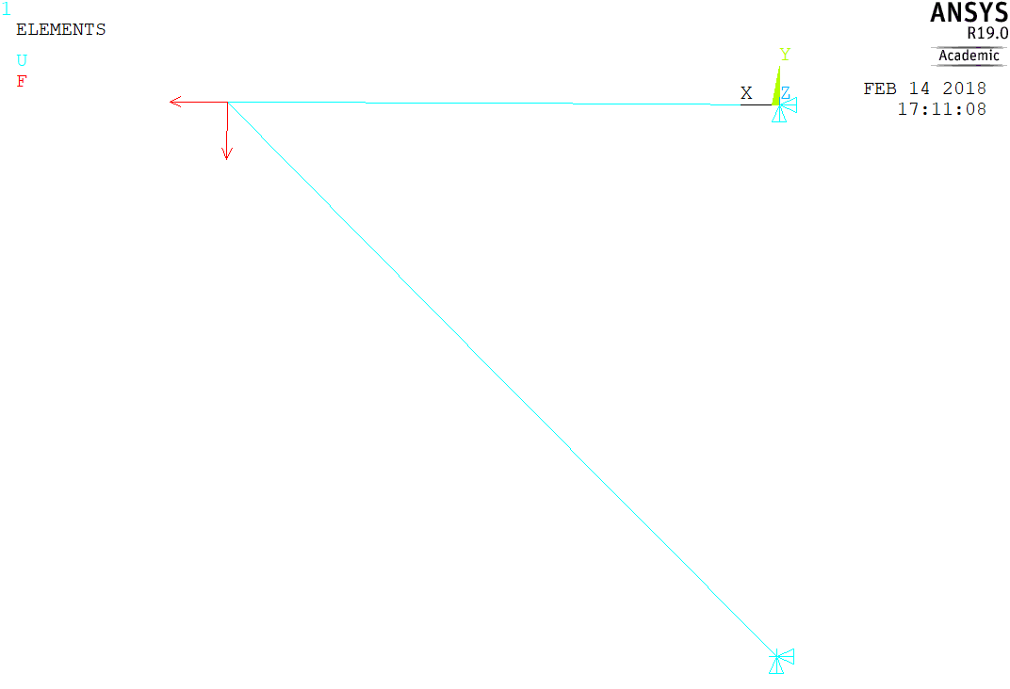

* **Results** *(40 points)*
  + 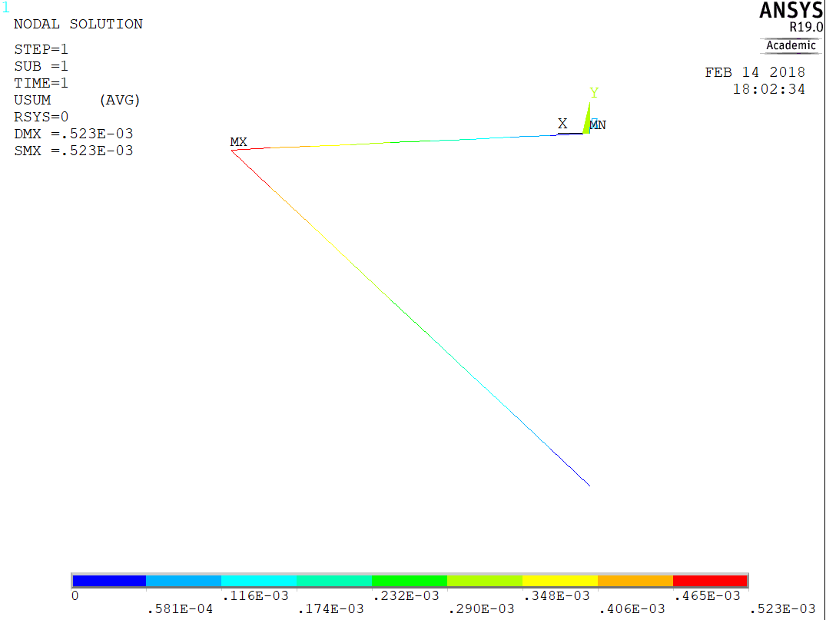Show a plot of the deformed shape.
  + Note the maximum stress in the structure and its location.

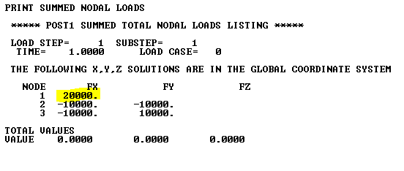

* + Report the nodal displacements and element forces.

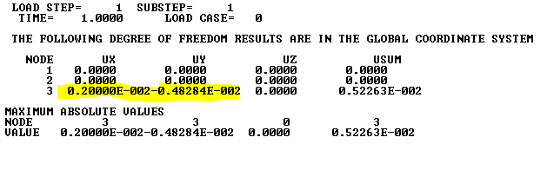

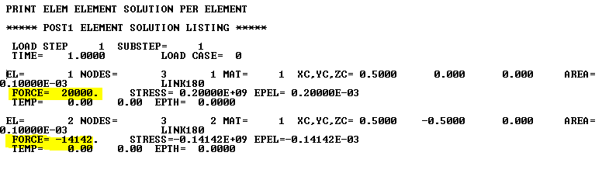

Max Stress

Hand calculations are done in the homework set.

* **Discussion** *(40 points)*

The main results that we need to analyze, as engineers in this truss are displacements and forces in elements, other parameters might be bring to our attention. From a logical point of view, displacements in the node 3 make totally sense, if we compare this results with the homework results we will see different directions of deformation but it just a sign convention matter. Speaking of forces, the program it shows the element 1 in tension and 2 in compression as we have predicted in our homework problem.

This problem is a truss element analysis, where every element could be consider a cell of the FEA problem. We could divide the element in multiple cells, but it would not make a huge difference since we are calculating displacement in the nodes and forces in the element are going to be constant all the way through it.

Many similar situations can be found in real live; however FEA methods might not be need it to solve such a simple case.

My main differences in the results were due to my sign convention set up and round error. Because of the simplicity of the problem error were not found critical.

**Conclusion** *(5 points)*

The results obtained for this problem are:

Displacement of node 3: $0.002 m \left(↓\right) \& 0.0048 m (→)$

Forces in element 1: $20 000 N \left(Tension\right)$ and in element 2 $14 142 N \left(Compression\right)$

So far, we can say that mechanics of materials problems can be very easy implemented and solved by FEA methods; however critical and logical thinking needs to be applied on the results.